ONEWAY CS BY FPS
/STATISTICS DESCRIPTIVES HOMOGENEITY WELCH
/PLOT MEANS
/MISSING ANALYSIS.

Oneway

Notes
Output Created |  | 06-May-2019 00:00:36
Comments
Input | Active Dataset | DataSet0
Input | Filter | <none>
Input | Weight | <none>
Input | Split File | <none>
Input | N of Rows in Working Data File | 30
Missing Value Handling | Definition of Missing | User-defined missing values are treated as missing.
Missing Value Handling | Cases Used | Statistics for each analysis are based on cases with no missing data for any variable in the analysis.
Syntax |  | ONEWAY CS BY FPS  /STATISTICS DESCRIPTIVES HOMOGENEITY WELCH  /PLOT MEANS  /MISSING ANALYSIS.
Resources | Processor Time | 00 00:00:00.172
Resources | Elapsed Time | 00 00:00:00.158

[DataSet0]

Descriptives
 | N | Mean | Std. Deviation | Std. Error | 95% Confidence Interval for Mean
 |  |  |  |  | Lower Bound | Upper Bound
30 FPS | 13 | 38.4615 | 3.47887 | .96487 | 36.3593 | 40.5638
60 FPS | 17 | 38.3529 | 2.69122 | .65272 | 36.9692 | 39.7366
Total | 30 | 38.4000 | 3.00115 | .54793 | 37.2794 | 39.5206

Descriptives
 | Minimum | Maximum
30 FPS | 28.00 | 40.00
60 FPS | 33.00 | 40.00
Total | 28.00 | 40.00

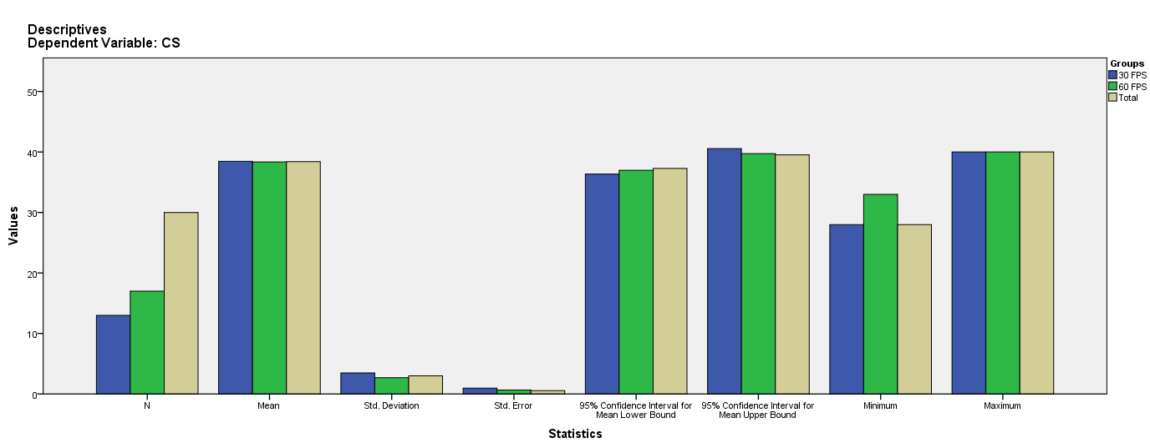

Test of Homogeneity of Variances
CS
Levene Statistic | df1 | df2 | Sig.
.004 | 1 | 28 | .952

ANOVA
CS
 | Sum of Squares | df | Mean Square | F | Sig.
Between Groups | .087 | 1 | .087 | .009 | .924
Within Groups | 261.113 | 28 | 9.325
Total | 261.200 | 29

Robust Tests of Equality of Means
CS
 | Statisticª | df1 | df2 | Sig.
Welch | .009 | 1 | 22.035 | .927
a. Asymptotically F distributed.

Means Plots

